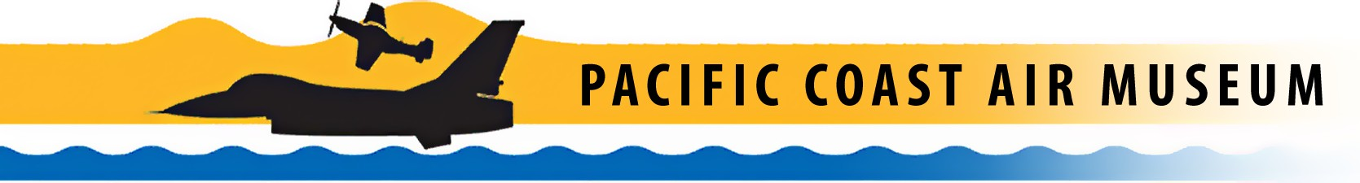

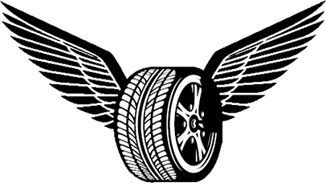
Wheels & Wings
2022 Car Show

Car Show Pre-Registration Form September 17, 2022
8am-2pm
- Pre-Registration Forms must be received on or before September 14, 2022
- Registration Fee: $25.00 per entry, includes 2 General Admission Wristbands
- Want to park next to your favorite museum aircraft? Additional $10.00 donation
- Registration Is Available At Pre-Staging Lot
- Registration Is Available online at PCAM website

**NOTE** Pre-staging lot is located at 3645 North Laughlin Road, ALL CARS must check-in at pre-staging area to receive wristbands. You will NOT be allowed in without your wristbands.
- Reminder to Car Clubs: A separate entry form must be submitted for each car entered
- Find out more at http://pacificcoastairmuseum.org/events/wheels-wings-car-show
Please Print Clearly Check One: □ Check □ Cash

First Name Last Name Mailing Address City State Zip Email Phone ( ) Make Model Year Car Club Name (If applicable)

Name of aircraft to be parked by (additional $10.00 donation)
Liability Waiver: With this right to participate, I/we release the Pacific Coast Our Museum (PCAM), Charles M. Schulz-Sonoma County Airport (STS), City of Santa Rosa, Sponsors and all others who may be concerned from any liability or injury or losses to myself and/or family during the event on Saturday September 25, 2021. I also consent to the free use of my name, likeness and image for any purpose.

Signature of entrant Date
Please mail a signed copy of this form and your entry fee to:

Pacific Coast Air Museum
Attn: Wheels and Wings Car Show One Air Museum Way
Santa Rosa, CA 95403 707-575-7900
Questions Contact: Chris Brown
707-695-8261
cb_custom@yahoo.com

The Pacific Coast Air Museum is a tax exempt organization under section 501C(3) of the IRS code.
The museum’s tax id number is 68-0216262.
One Air Museum Way • Santa Rosa, California 95403
707-575-7900 • Fax 707-545-2813 www.pacificcoastairmuseum.org
© Copyright 2021 Pacific Coast Air Museum http://pacificcoastairmuseum.org 707-575-7900

